**MMXM TRADING SERIES: MODELS AND RISK MANAGEMENT**

We are talking about a model here and we don’t base on the core concepts... so we follow up with model labeled in the MMXM traders model

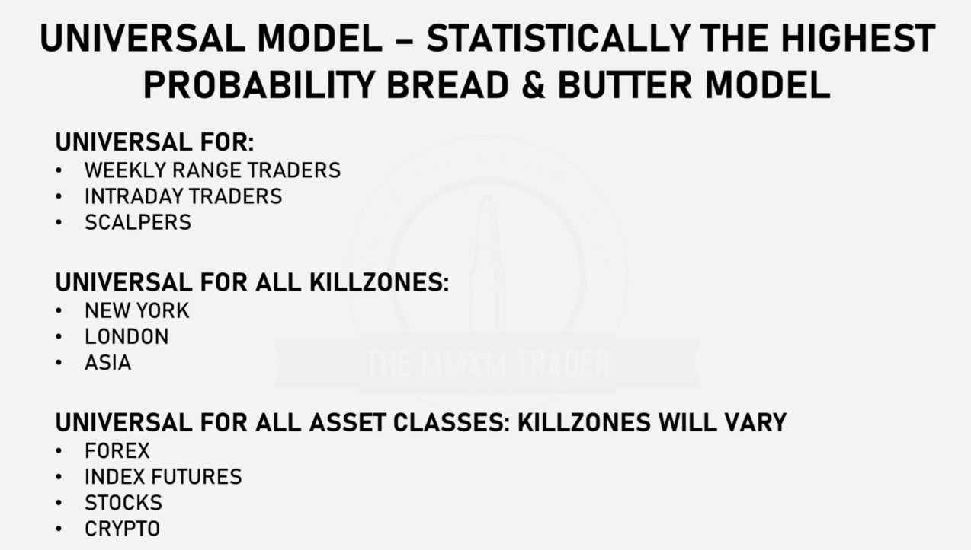

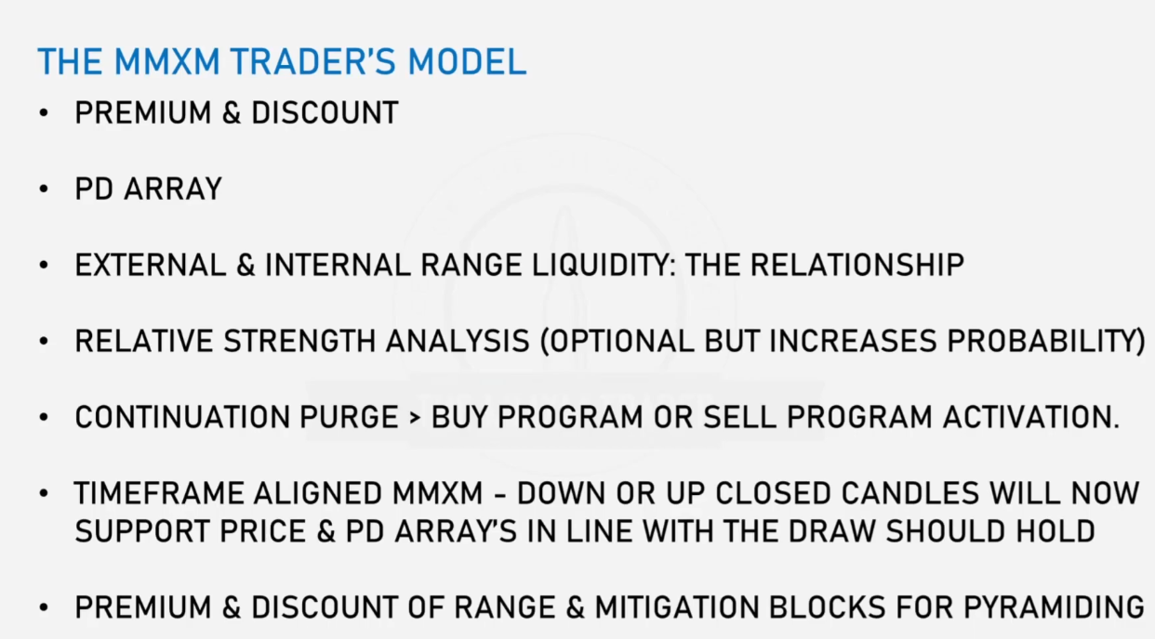

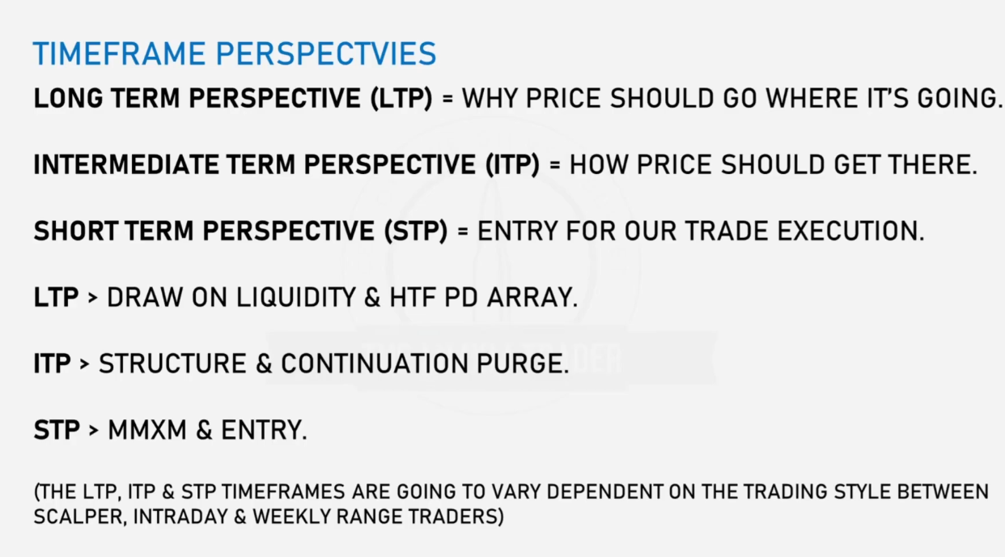

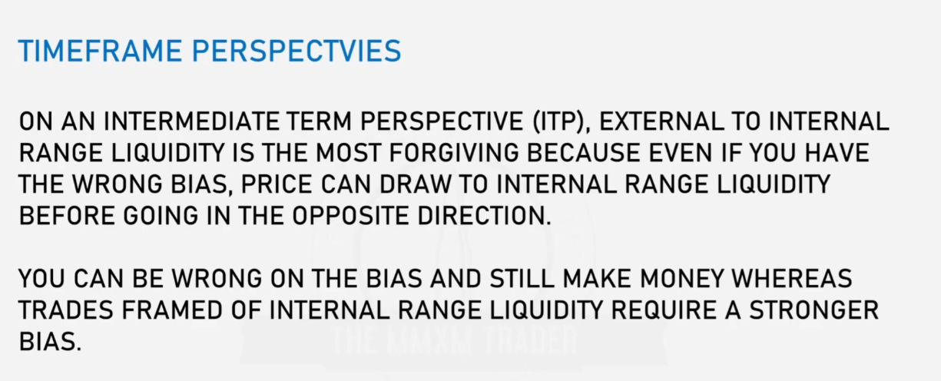

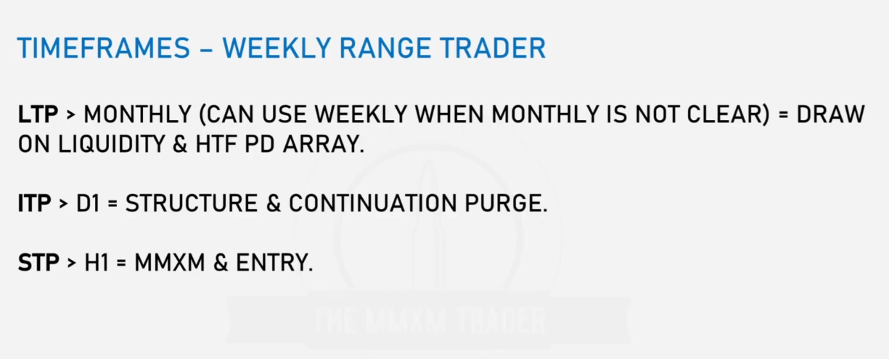

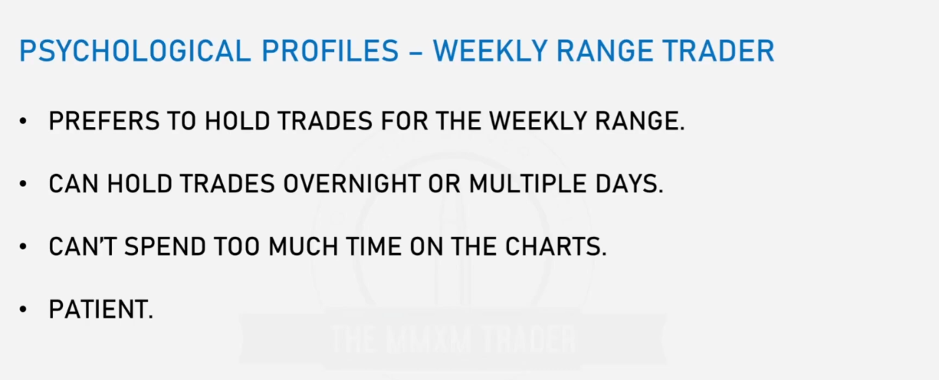

**UNIVERSAL MODEL: EXAMPLE 1**

Given the weekly chart

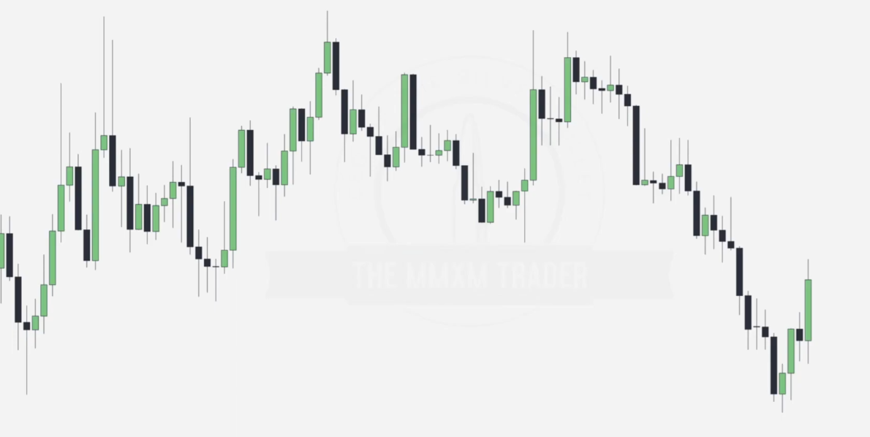

Mark the ERL points on the weekly chart... note the sell stops accumulation and the FVG tapped into after.

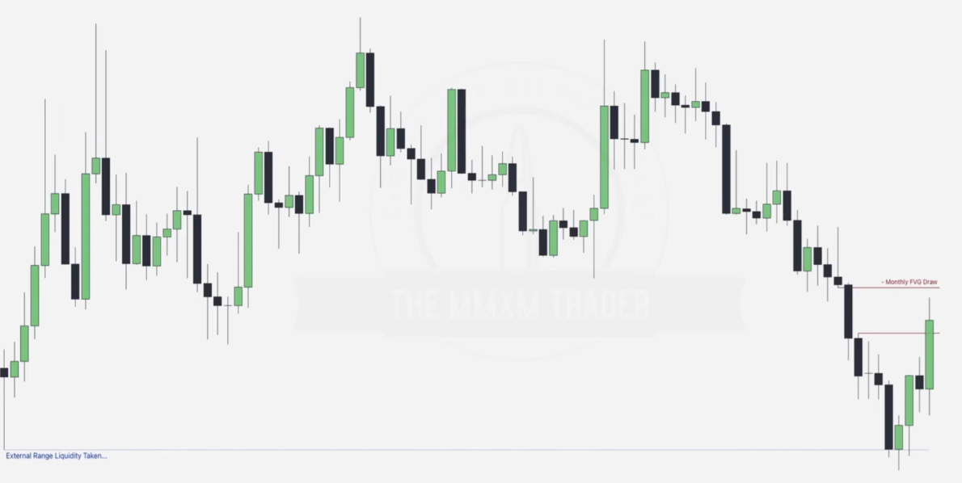

Going to the daily chart

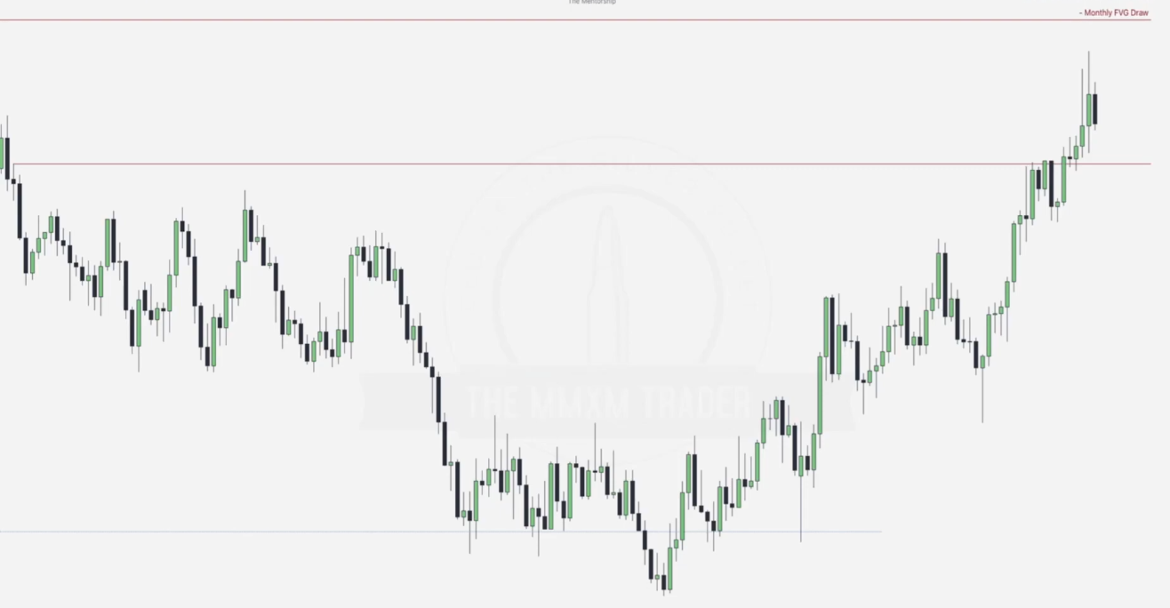

Note sell stops, order pairing and the break in structure.. as below.. in addition we need to make sure our ITP aligns with the LTP(proving the bullish nature).

We can confirm continuation using the second order pairing of the day.. noted as D1 continuation purge..

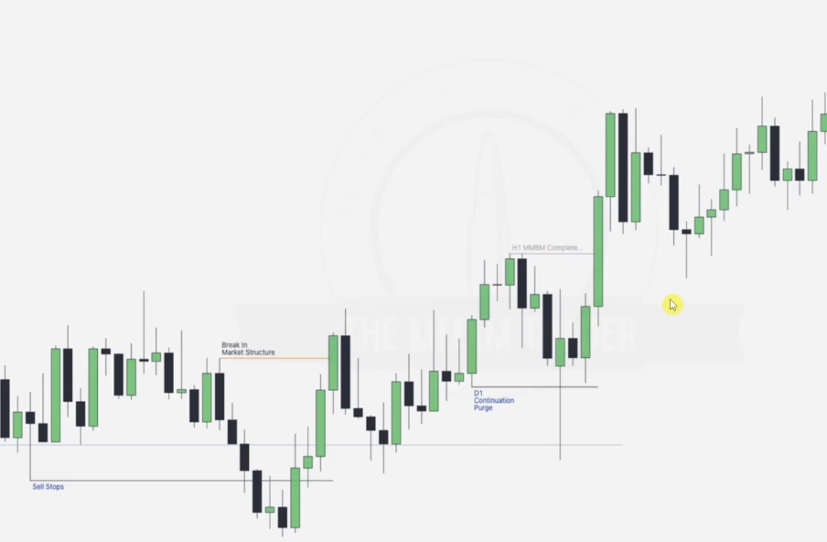

In order to make an entry we go to STP... AND we use the H1 MMBM Complete from the previous graph as below

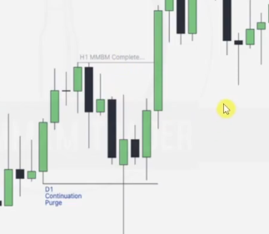

Now we need to go to the hourly chart to start working on the MMBM as below... here the accumulation zones are marked.. remember the first consolidation marks the buy stops we can base on chasing..

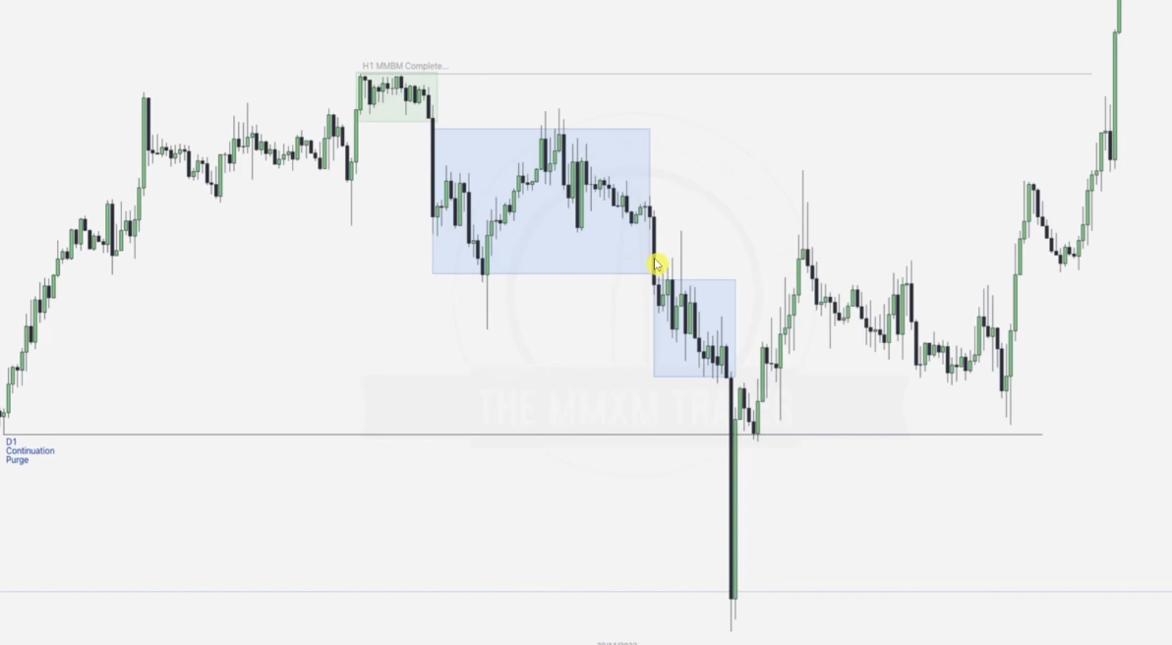

Now lets look at the order pairing and the ERL it will hunt.. failure swings as indicated below

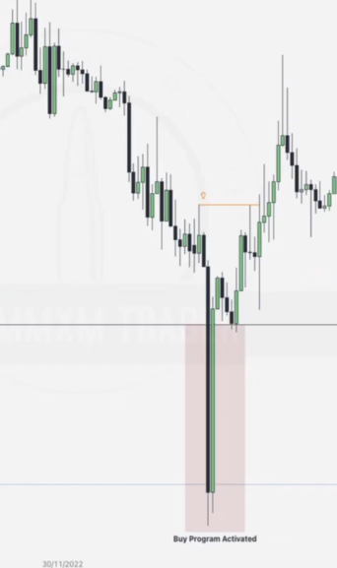

Next step is noting this down-closed OB.. this can be an entry point since it supports price higher... but we notice that there is some retracement after that... can we make an entry here too..

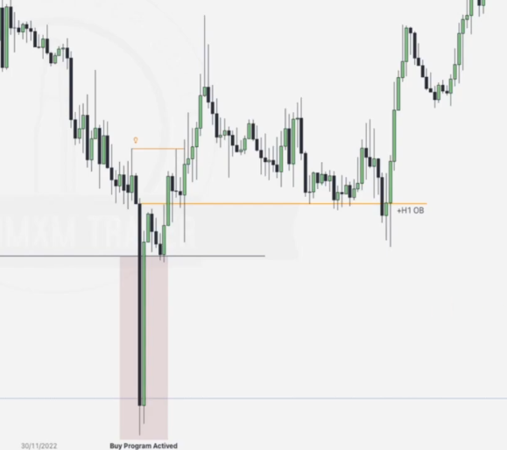

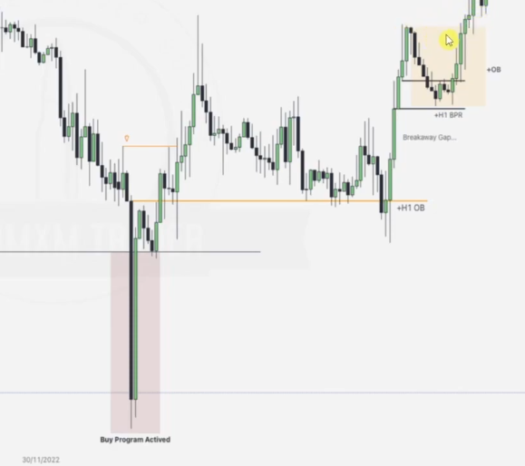

Note that there is a BPR and down-closed OB confluencing at this point as a result... this is a very good point for an entry...also note the breakaway gap.. they come in a pair.

Going back to the daily chart.. we note that there is a seconf daily continuation purge from which we can form another MMBM for entry.. as below

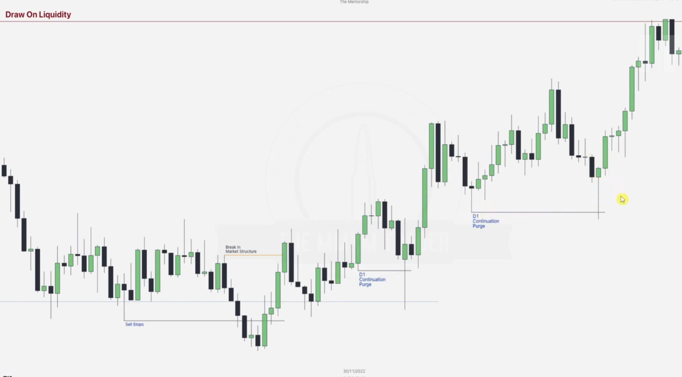

In the new MMBM.. note down the accumulations and consolidations(forming the highest sell stop).. monitor the failure swings.. order pairing and the break in structure.. can be an entry.. then now we hunt for new entry points.. using all the core concepts ++

First step was noting the mitigation blocks on the sell side of the market as per this Universal model.. note that there are OBs in-line with the mitigation blocks forming confuences with high probability OBs

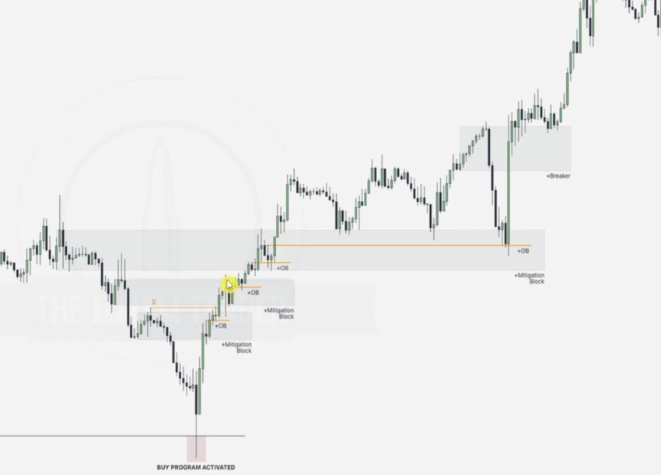

AMD will happen.. part of market behaviour .. also note the breaker block as below

